Lucas Swanson
10/26/2025
Programming Languages I
Exercise 4
Exercise 4.1: Scope
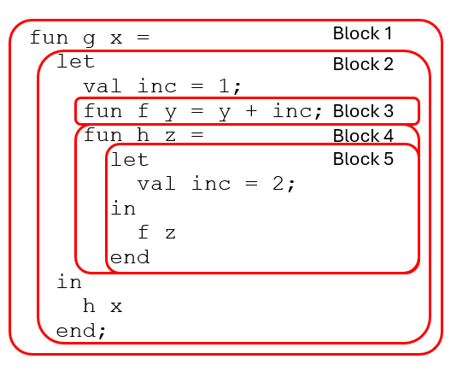
This diagram of a function highlights five different blocks.
Name Definitions:
- Name: “g”
  - Scope: Block 1
- Name: “x”
  - Scope: Block 1
- Name: “inc”
  - Scope: Block 2
- Name: “f”
  - Scope: Block 3
- Name: “y”
  - Scope: Block 3
- Name: “h”
  - Scope: Block 4
- Name: "inc”
  - Scope: Block 5
Name Utilizations:
- Function name “h” is called passing “x”
  - Function “h” is set by block 4
- Function name “f” is called passing “z”
  - Function “f” is set by block 3
- Function “f” passes back the input plus name “inc”
  - No definition for “inc” exists in block 3
  - Function “f” will look for a definition for “inc” in a higher block
  - Definition for name “inc” exists in block 2
  - Name “inc” will be value 1
Notice how even though a definition for “inc” exists in the most nested block, it is not used? This is due to that not being utilized in the block at all passing anywhere. We could change this functionality by linking block 5 and block 3 by passing function f two inputs, z and inc.

Exercise 4.2: Type Construction
Write a datatype definition for a type suit whose values are the four suits of a deck of playing cards.
Next, use your definition to write a function suitname of type suit -> string that returns a string for the name of a suit
(* Enumeration *)
Datatype suit = Spade | Club | Heart | Diamond;

fun suitname Spade = "Spade"
| suitname Club = "Club"
| suitname Heart = "Heart"
| suitname Diamond = "Diamond"
| suitname _ = "Not a Suit";
suitname Spade;
Exercise 4.3: Memory
For each of the following ML functions, could the activation record for the function be deallocated as soon as the function returns? Explain why or why not.

Long story short: The answer will only be no when a value or activation record needs to exist even after a function has been returned.
- fun f x = x + 1;
  - Yes. Safe to reallocate
    - There will no longer be any calls to the record containing the value of “x”. It is safe to reallocate this activation record
- fun f x = fn y => x + y;
  - Yes. Safe to reallocate
    - While this does have a depth of two, after each activation, the records for x and y are no longer utilized.
    - This does however utilize static linking for function “y” to retain the input value of x.
  - No
    - This breaks however if you were to late in line define
fun increment = f 1;
This would mean that for further calls of “increment” would wipe the value of “1” when it was called the first time.
- fun f x = fn y => y + 1;
  - Yes. Safe to reallocate
    - Again, depth of two but no need to keep the records for y. Also no static linking needed.
- fun f x = map ~ x;
  - Yes. Safe to reallocate
    - As each call of “f”, “map” and each recursive call of “map” gets its own activation record and does not need any other references, they can be reallocated once returned.

